***Supported Browsers****: Firefox, Chrome, IE, Safari, Opera*

***Operating System****: Microsoft Windows, Apple OS X, Linux*

**Steps to run using selenium grid** :-

```````````````````````````````````````````````````````````````````

1. Download the Selenium Server jar file from the following link

<http://www.seleniumhq.org/download/> (Download version : 3.4.0)

1. Open the command prompt and navigate to the folder where the downloaded server jar file is located.

( For eg : cd C:\Server Jar )

1. To launch the **hub** run the server using the following command

**Java -Dwebdriver.chrome.driver=C:\drivers\chromedriver.exe -jar selenium-server-standalone-3.4.0.jar -role hub**

**[Note :** For other browsers ,download the driver files from the following link

<http://www.seleniumhq.org/download/>]

4. Status of the **hub** can be checked by the following web interface

<http://localhost:4444/grid/console>

5. Go to the other machine where we want to setup the **node** and open the

Command prompt and run the following command

***Java* -Dwebdriver.chrome.driver=C:\drivers\chromedriver.exe *-jar* selenium*-server-standalone-3.4.0.jar -role node –hub*** [**http://localhost:4444/grid/register -port 5556**](http://localhost:4444/grid/register%20-port%205556) (In the place of local host give the IP address of the machine where the hub is launched)

6. After starting the **node** we can check the nodes connected to **hub** and

The available browsers in the grid console.

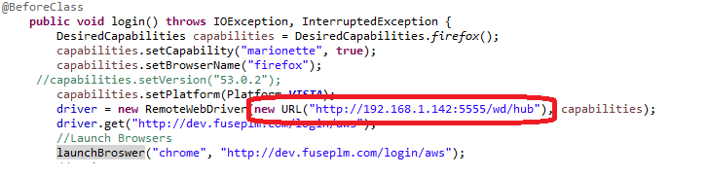

7. In Code, change the **Hub** URL while changing or using as **hub** machine.

8. On launching the **hub**, we can run on the node machine without Eclipse IDE

**Create a batch file :-**

**``````````````````````````**

1. Open the notepad

2. Copy the following command and save the file type as bat.

**Java -Dwebdriver.chrome.driver=E:\drivers\chromedriver.exe -jar selenium-server-standalone-3.4.0.jar -role hub**

3. Follow the above steps for both hub and node machine.

4. Now double click the created bat file.